

**Year 12 Legal Studies**

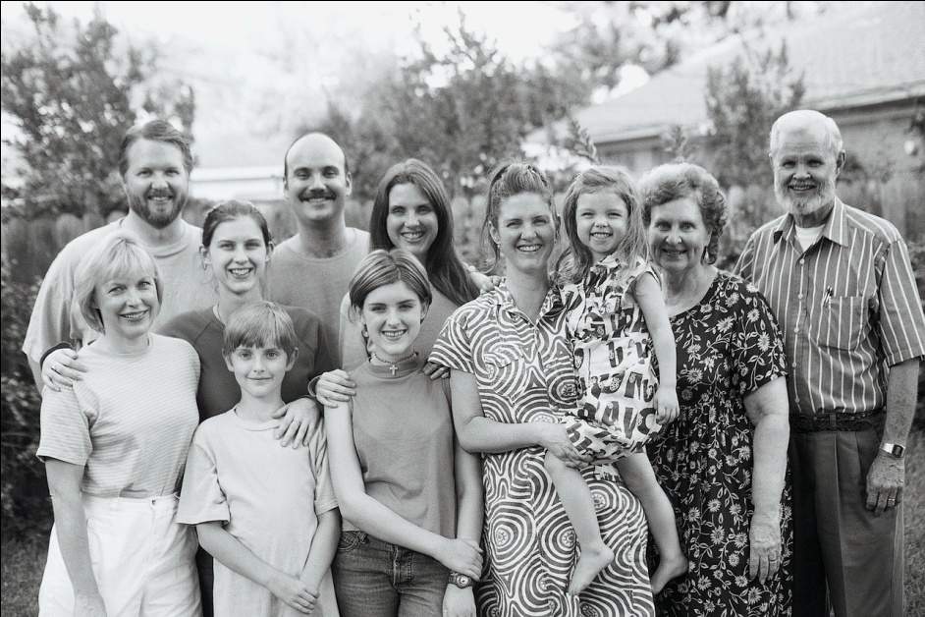

**Family Law**

**Non-Written Presentation**

**Research Booklet**

**Student Name: _____________________________Guidelines for the task**

##### Knowledge and Understanding

Define the problem or issue, which you are investigating. State the relevant laws, which currently apply to this issue. Identify, summarise and explain existing state of law (if relevant, in comparison to previous laws or the laws of other jurisdictions), including its sources, function and purpose.

##### Investigation

Identify the main legal principles that relate to the topic and analyse whether the current applications of the legal principles to the matters in dispute provide legally justifiable responses and solutions. Analyse the results of your research and comment on the views reflected in your findings.

***Evaluation***

Comment on how effectively the current law deals with competing social interests in our community. Make and justify recommendations for improvements in the law that will serve the competing social interests in the fairest way in the future. What reforms do you envisage as essential? What are the legal and social consequences of these reforms? Are these reforms acceptable to our present society and our current legal system? ie. Justify these reforms (Consider justice, fairness, ethics, and limitations of our legal system)

##### Communication and Research Skills

Communication should be sequential and fluent. Ensure language conventions are correctly used and legal terms are stated clearly, concisely and accurately.

**Requirements of the task**

1. You are required to choose a current, relevant issue of your choice from the suggested area of study (from the list given or in consultation with your teacher).
2. From the topic chosen you will develop a well reasoned hypothesis which must then be negotiated with your teacher.
3. Conduct research into this topic and make sure that it is current and reliable. Determine what information can be used in this presentation. Draft a non written presentation based on this information. Make sure that you leave enough time to amend your final presentation based on the feedback from your teacher.
4. It is recommended that you include current case studies/cases/statistics in your appendix that may be referred to in your presentation.
5. Your investigation into the issue should then produce a well reasoned and documented non written presentation covering all criteria as outlined above and on the standards matrix. Please ensure that you offer suggestions/conclusions in regard to your argument.

**SUGGESTED AREAS OF STUDY**

**The following topics and areas of study may be helpful for initial selection of your topic. Highlight the issues below that are of interest to you.**

**Finally, choose one topic only – you may negotiate another area of study with your teacher. Please note the questions below for each topic are guide questions only. It is expected that you will establish a strong hypothesis on the basis of your research.**

1. **Marriage** – What law governs marriage? Who is eligible to marry? What are the requirements to become legally married? What are the changing patterns and social practices towards marriage? Is the law reacting to social pressure or merely acting as a modifying influence?
2. **Financial Agreements (pre-nups)** – What is the law related to the making of a financial agreement? When may these be useful. Examine the arguments for and against these agreements.
3. **Divorce** – Some say it is easy to marry, but it is not so easy to get unmarried. Do you agree? What laws govern divorce? What are the grounds for divorce? What are the laws regarding division of property when a marriage is dissolved? Analyse the legal rights of children following parental separation and divorce. Does the law go far enough to ensure that children’s rights are protected?
4. **De Facto** – What legal rights do spouses and children of de facto relationships enjoy? What is the law relating to ex-nuptial children when the parents’ de facto relationship breaks down? Does Queensland have a De Facto Relationships Act? Do other states? How do they compare?
5. **Fathers** - Fathers are sometimes the forgotten party when decisions regarding children are concerned. What legal rights do fathers have over the unborn child? Can a father of a child conceived out of wedlock legally have a say in whether or not a child can be put up for adoption? Does the Family Law Act and Family Court decisions discriminate against fathers in custody decisions? What social changes have affected the courts decisions? Examine if there is a need for reform in this area of law?
6. **Birth** – What happens when a child is born? What are the legal requirements for notification of a birth? What are the functions of the Registry Office? Under what legislation does this office operate? What is the legal position of a child not born within a marriage? To what extent does Family Law in Australia protect the rights of the unborn?
7. **Surrogate** – What are Queensland’s laws? Compare these laws with the legal situation in other states. Analyse them to determine the adequacy of meeting the demands of today’s society. Examine the problems with legalisation of this process.
8. **IVF/Artificial Insemination** – The conception of women by means other than sexual intercourse carries with it a complex array of social, moral, religious, ethical and legal questions. Analyse the legal framework as it now applies. What are the current laws in Australia? Who bears the responsibilities of parenthood? What is the laws/regulations dealing with the freezing of embryos for future implantation or research. Is there room for law reform and if so, what direction should it take?
9. **Adoption** – What are the laws and regulations relating to Australian adoption? What is the legislation that governs this activity? What are the legal issues involved when an adoptee wishes to locate his/her natural parents – or vice versa? To what extent is the law and its interpretation adequate?
10. **Overseas Adoption** – Explain the law governing the adoption of foreign children by Australian resident citizens. What are the implications both for the individuals concerned and for the Australian society generally?
11. **Foster Children** – Under what circumstances does a child become a foster child or ward of the State? Who decides on the placement of foster children and how do families become foster families?
12. **Child Care** – What family issues give rise to an increase in child care requirements? What is the current law cover chid care providers? How does the law look after the safety and well-being of a child? Who can register to provide a child care service and what does the law require of this person/business?
13. **Parents** - What are the laws regarding the duty of care that parents have to care for their children? What are the laws regarding parental responsibility for children, particularly their criminal acts?
14. **Children** -What is the law on the age of majority? When does a child become an adult for various activities – i.e. age of consent, age of criminal responsibility, buying alcohol or cigarettes, getting married, working? Examine the legislation and rules that regulate these behaviours. Are the laws realistic and fair – justify your reasons.
15. **Youth** – At what age can a young person legally leave home? Why are some youth homeless? Can a young person be forced to go home? What alternatives are there? Do parents of a runaway youth have any rights? Which government department is responsible for child welfare issues in Qld. What is the scope of their responsibility?
16. **Single Parents** - What are the laws and regulations relating to support for single parents and low-income families? How are these people supported by government organisations? Which particular government organisations administer this assistance?
17. **Wards of the State** – Analyse the legal rights of all parties concerned with the transfer of legal custody of children from parents/guardians to the State. What situations would give rise to this procedure? Is the current system working in the best interests of all?
18. **Child Abuse** – To what extent is child abuse a problem in Australian society? What factors contribute to child abuse? What is the law doing both to help reduce the extent of the problem and to help rehabilitate the victim? Analyse the Child Protection Act thoroughly. Examine the legal rights of children, parents and witnesses associated with child abuse.
19. **Domestic Violence** – What is the law relating to domestic violence? What protection is available to those who suffer it? Include a discussion of emergency assistance. What laws are involved and what government organisations administer them?
20. **Family Court of Australia –** Over the years there has been considerable criticism of the Family Court of Australia. Trace its evolution. What are the current functions of the Family Court? What is the structure of the Family Court? What Act is it governed by? Evaluate any reforms which are or have been made which might have improved its image in Australian society.
21. **Family Law Reform Act** – This Act was designed to bring about certain important changes to divorce law. What are the rules regarding compulsory mediation in Family Law disputes? What is the law relating to parenting plans and financial responsibility of parents for care of children after marriage break-up?
22. **Death** – The death of a close friend/relative can be a very difficult time. What happens when a person dies? What are the legal requirements from the time of death until burial? What support mechanisms are in place to assist with dealing with the death and arranging all the necessary procedures?
23. **Wills** – To what extent are wills important in our society as a means of protecting our rights of inheriting private property? What is the law relating to the making of wills? What are the implications of intestacy?
24. **Enduring Power of Attorney** - What is the meaning of the term “Enduring Power of Attorney”? In what situations is it appropriate to have this in place?

**My topic is: ____________________________________**

**KWL Chart**

Before you begin your research, list the details in the first two columns. Discuss with the class where you will find appropriate research materials.

|  |  |  |
| --- | --- | --- |
| **Topic:___________________________________________________** | | |
| **What I Know** | **What I Want to Know** | **Where I Will Look** |
|  |  |  |

**Formulate Hypothesis Statement**

From your background reading/researching you will need to develop a Hypothesis Statement.

A **HYPOTHESIS STATEMENT** is a statement made as a starting point for further investigation. It is made on the basis of known facts.

It uses the process of **INDUCTIVE REASONING**. This means to make general conclusions from specific information or observations.

**EXAMPLE USING HOMOSEXUAL MARRIAGES**:

Currently under both federal and state legislation people of the same sex are not allowed to be married, however, in many overseas nations this practice is accepted. This inequity should be addressed to allow homosexual marriages in Australia.

Outlining your Hypothesis Statement

**Identify** in the space below your statement and have your teacher approve it.

This statement will probably be subject to change as your research on the topic progresses.

Therefore, you may need to re-assess your statement and re-write it. A space has been provided if you find this necessary.

Hypothesis Statement:

______________________________________________________________

______________________________________________________________

______________________________________________________________

______________________________________________________________

______________________________________________________________

Teacher approval:_____________________ Date: ____________

Changed Statement

______________________________________________________________

______________________________________________________________

______________________________________________________________

______________________________________________________________

______________________________________________________________

Working Questions

MCj02150270000[1]

Please outline below the working questions that you will research. The list is not limited to 6 questions. Please use your own paper to continue if necessary.

1. ________________________________________________________________________________________________________________________________________________________________________________________________________________________________________________________________
2. ________________________________________________________________________________________________________________________________________________________________________________________________________________________________________________________________
3. ________________________________________________________________________________________________________________________________________________________________________________________________________________________________________________________________
4. _______________________________________________________________________________________________________________________________________________________________________________________________________________________________________________________________
5. ________________________________________________________________________________________________________________________________________________________________________________________________________________________________________________________________
6. __________________________________________________________________________________________________________________________________________________________________________________________________________________________________________

**Check by Teacher**: ___________________ **Date**: ____________

**Analysing Perspectives**

**The process of identifying multiple perspectives on an issue and examining the reasons or logic behind each. This is helpful when completing requirements for the evaluation criteria**

The process:

1. Firstly, identify and clearly articulate the perspective of the first stakeholder you have chosen.
2. Once you have identified their perspective, try to determine the reasons or logic behind it.
3. Provide evidence of their reasoning through research. This can be quotes or lobby groups etc.
4. MCj03262260000[1]Next, identify and clearly articulate a perspective from a second stakeholder.
5. Try to describe the reasons or logic behind this second stakeholder’s perspective. Again this will entail support from research.
6. Continue with the same process for stakeholder 3. This process can be repeated for numerous stakeholders.

***Analysing Perspectives***

The goal of analysing perspectives is to fully understand the reason or logic for another persons/groups position on the issue. You may need to include more than four stakeholders.

|  |  |  |  |
| --- | --- | --- | --- |
|  | **Their Perspective** | **Reason for the Perspective** | **Supporting Evidence** |
| **Stakeholder One:** |  |  |  |
| **Stakeholder Two:** |  |  |  |
| **Stakeholder Three:** |  |  |  |
| **Stakeholder Four:** |  |  |  |

**Y Chart**

Complete the chart outlining both the advantages and disadvantages of the *current legislation*. Draw from all the research material that you have found in relation to the legislation.

**Disadvantages**

**Advantages**

**Conclusion/ Recommendations**

Research Planner and Log Book

Fill in the log book below by detailing what research and work was completed each lesson.

Week One

|  |  |  |  |  |
| --- | --- | --- | --- | --- |
| Lesson 1 | Lesson 2 | Lesson 3 | Lesson 4 | End Wk 1 |
| GET THE ASSIGNMENT  TASK  Discuss in class | Work through the assignment booklet  - planning  - topic choices  - booklet  - writing questions  Consider TOPIC and do preliminary research on what you think you would like to do! | Narrow down  your topic choice | Topic must be chosen and approved by your teacher.  Explore your current knowledge of this topic and particular areas of interest. | Prepare your hypothesis. This should be checked by your teacher and revised based on comments received. |

Week Two

|  |  |  |  |  |
| --- | --- | --- | --- | --- |
| Lesson 1 | Lesson 2 | Lesson 3 | Lesson 4 | End Wk 2 |
|  |  |  |  | Develop a number of working questions that are related to your hypothesis. Make sure that your areas for research cover the criteria being assessed.  Undertake investigations to gain access to a diverse range of resources to obtain relevant information.  Include statistics and data analysis where possible. |

Week Three

|  |  |  |  |  |
| --- | --- | --- | --- | --- |
| Lesson 1 | Lesson 2 | Lesson 3 | Lesson 4 | End Wk 3 |
| Draft due in consultation with your teacher |  | MCj03967440000[1] |  | Collect, organize, analyse and synthesise your accessed information to answer your working questions.  Draft will be checked by your teacher during this week. Peer drafting is also recommended |

Week Four 25/2 – 1/3

|  |  |  |  |  |
| --- | --- | --- | --- | --- |
| Lesson 1 | Lesson 2 | Lesson 3 | Lesson 4 | End Wk 4 |
|  |  |  | PRACTICE  PRACTICE PRACTICE PRACTICE PRACTICE PRACTICE | **Presentations Start 3rd March** |